Kollective SCCM Integration Project Code Build
Client: Kollective



Sl# | Date | Description | Author
1 | 22nd March 2016 | Instruction for building codebase | Juien

Table of Contents
How to build SCCM project 4
Web application for Preload activities 4
SCCM handler 8

How to build SCCM project

The Kollective SCCM Integration product consists of two web projects. They are
- Web application for Preload activities
- SCCM handler

Prerequisite:
Need a system with Visual Studio 2013 and SQL server 2012 client. Need to connect the SQL server and install the database for SCCM.
SQL Script for installing DB:
Need to run the following script into SQL server Query window
IF NOT EXISTS (SELECT name FROM master.dbo.sysdatabases WHERE name = N'SCCMDB')
CREATE DATABASE [SCCMDB]

GO
USE SCCMDB;
create table tblContentInfo
(
content_id varchar(50),
content_file_name varchar(50),
content_moid varchar(50)
)

It will generate DB as well as the table in SQL Server

Web application for Preload activities
This web application is created for the add-on activities of SCCM DP. It consists of two tab, one is for pre-loading the contents into Kontiki eCDN and another is the log monitoring tool.
Codebase Directory name: KontikiPrepositioning
STEPS:
- Debugging and building project (KontikiPrepositioning)
- Open the directory KontikiPrepositioninga nd double click on the solution file (KontikiPrepositioning.sln).
- The solution will open in Visual Studio 2013. There are three projects inside the solution.
- BusinessLogic (Class library project)
- DataAccess (Class library project)
- KontikiPrepositioning (Web project)
The solution explorer looks like
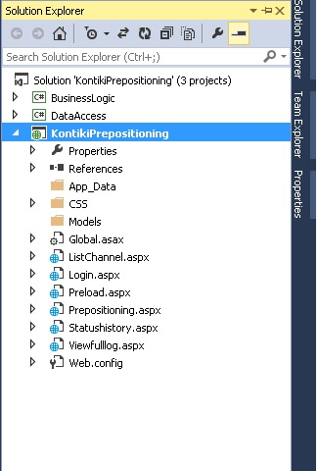
- Right click on each project separately and click on Build and it will successfully build each of the projects. It will give message at the end left corner of the editor “Build Succeeded”.
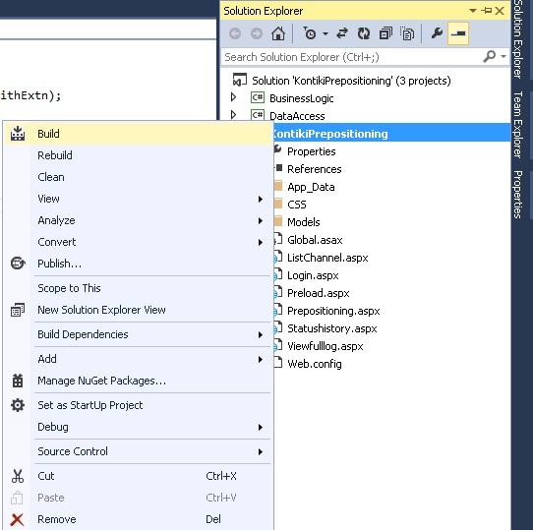
- Open Web.config file from KontikiPrepositioning project and modify the config variable as per local system’s setting. Need to change the connection string
<add key="ConnectionString" value="Data Source=SKRLABDP02;Initial Catalog=SCCMDB;Integrated Security=true; Connect Timeout=30000" />
Data Source = SQL server name or IP address
Initial catalog = database name
- Modify the SCCM content library path in Web.config (if required)
<add key="SCCMContentLibraryPath" value="F://SCCMContentLib" />
SCCMContentLibraryPath= the path where SCCM is installed i.e. SCCMContentLib directory is located.
- <add key="SCCMDPConfigpath" value="D:\JUIEN\WixProjs\WIXInstallerDemo-master\DemoWebsite\web.config"/>
The value of “SCCMDPConfigpath” will be the path of web.config file of SCCMWeb.
- Change the others variable as per requirement like logfile path location, SCCMHttppath etc.

- Open “KontikiPrepositioning” project and right click on “Preload.aspx” file and click “Set As Start Page”
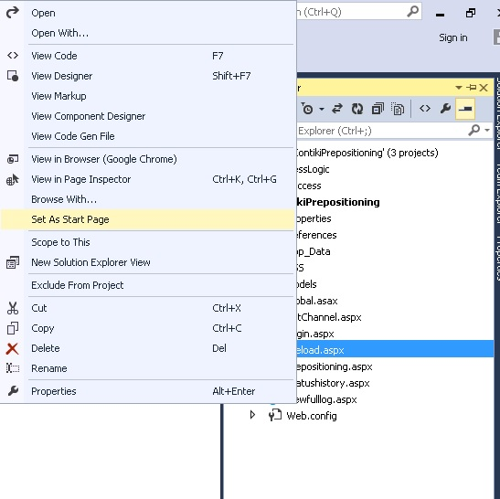

- Click on Debug → Start Debugging from visual studio menu or press F5
- It will open the selected page into browser.

SCCM handler

This is a web application which consists of one webpage (.aspx) only. All works will be done from backend of that web page. Need to down the codebase directory for building it locally.

Codebase Directory name: WixProjs
STEPS:
- Debugging and building web project (SCCMWeb)
- Open the directory WixProjs
- Double click on the solution file (DemoWebsite.sln) which is inside WixProjs → WIXInstallerDemo-master
- The solution will open in Visual Studio 2013. There are two projects inside the solution.
- DemoWebsite.setup (WIX installer project)
- SCCMWeb (Visual studio handler project)
The solution explorer looks like

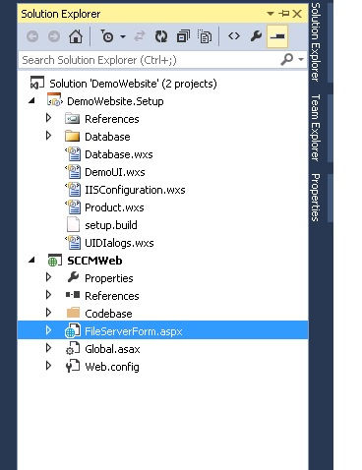
- Right click on SCCMWeb project and click on Build and it will successfully build the project. It will give message at the end left corner of the editor “Build Succeeded”.
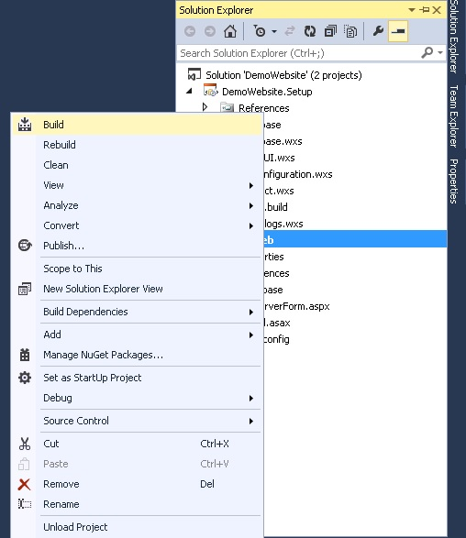
- Open Web.config file from SCCMWeb project and modify the config variable as per local system’s setting. Need to change the connection string
<add key="ConnectionString" value="Data Source=SKRLABDP02;Initial Catalog=SCCMDB;Integrated Security=true; Connect Timeout=30000" />
Data Source = SQL server name or IP address
Initial catalog = database name
- Modify the SCCM content library path in Web.config (if required)
<add key="SCCMContentLibraryPath" value="F://SCCMContentLib" />
SCCMContentLibraryPath= the path where SCCM is installed i.e. SCCMContentLib directory is located.
- Change the others variable as per requirement like logfile path location, SCCMHttppath etc.
- Right click on “FileServerForm.asps” page inside SCCMWeb project and select “Set as Start page”. It will set the page as default start page.
- Click on Debug → Start Debugging from visual studio menu or press F5

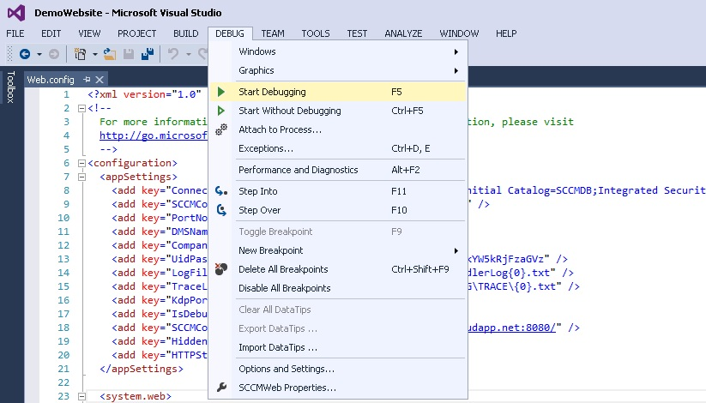

- It will open the page into browser. Need to set breakpoint if you want to debug the code as there is no UI for observing the changes or steps.

- Building WIX installer project (DemoWebsite.Setup)
- There is a directory called “KontikiPrepositioning” inside “WixProjs\WIXInstallerDemo-master\DemoWebsite.Setup”. Need to copy the current files of KontikiPrepositioning into this folder. The files need to copy are
- All .aspx pages into the root directory
- All .DLL files into bin directory inside root
- All images files and style.css file into CSS folder inside root
- Open Developer Command Prompt (Start → Visual Studio 2013 → Visual Studio Tools → Developer Command Prompt for VS2013)
- Copy the path of the directory DemoWebsite.Setup (WixProjs\WIXInstallerDemo-master\DemoWebsite.Setup)
- Set the command prompt’s directory as the path of DemoWebsite.Setup.
- Run the following command in Developer’s command prompt:
set WiXPath=C:\Program Files (x86)\WiX Toolset v3.10\bin\

- Run the following command after that:

msbuild /t:Build;PublishWebsite;Harvest;WIX setup.build
It will give the success message.

- It will generate MSI file (SCCMWeb_Setup.msi) on the following path “WixProjs\WIXInstallerDemo-master\DemoWebsite.Setup\bin\Release”

- Double click on the msi file to install the application.

